

Automatic Green house system

TPJ452 Project Proposal



Course: TPJ452

Instructor: Gal Messinger

Group Number: 2

Group Members: Huang Zheng, Yu Chen

Member’s STD#: 025-775-115, 046-158-143

Date: Nov 30, 2016

Table of Contents

1. Project Description 2

2. Background 2

3. Problem Statement 3

4. Project Goals and Objectives 4

5. Strategy 5

6. Block Diagram 6

7. WBS 7

8. GUI 9

9. Bill of Materials 10

1. Project Description

In this project we are going to design a greenhouse system, which will help the plants to have a best environment and growing up with the scientific method. In the system the sensors will detect and collect data of the soil moisture, air temperature, and light and give the corresponding feedback to environment to reach the expected effect.

We will use a LCD to display the current status and temperature and moisture of the environment. The system will connect to the cellphone app by the Bluetooth to control the system. In the interface, we are allowed user to see the info exactly same as the LCD, and user can use manual switch to control the system such as main switch, water pump, cooler and heater. As well, user will be able to set the temperature for the system.

1. Background

There is no such product on the market that could remotely control the green house system using a smartphone.

1. Problem Statement

In this course we are designing an Automatic Greenhouse System is very helpful for household. Assume a busy family want to eat fresh tomato (or other vegetables) that plant by themselves.

So they are plan to plant tomatoes in the backyard, but they don’t have much time to take care tomatoes. However, if this busy family have an automatic greenhouse system, they don’t need to worry this situation. They system will help them to watering, and provide a computable temperature for the plants.

And also it will help them to save a lot of time to work on other things.

1. Project Goals and Objectives

When system is powered on. The system will start to collect data and start to build a wonderful environment for the plants.

The plants growth needs Sun to make the photosynthesis. So we will install 4 light sensors that place on the top of the case, when morning is coming those 4 sensors will detect the light at same time to enable the cover that we installed on the top of the case, why we use 4 sensors? Because this will avoid the cover opened in the mistake.

Inside the case, there is a temperature sensor installed on the top side of the case, this will make sure the plants have a temperature that suitable for growth. On the cellphone app, we can set a corresponding temperature for the plant. However, when the temperature is higher than we set, the cooler will be activate by the system. Opposite, the heater will be activate when temperature is lower.

The water is very important for the plants, when soil moisture is lower than normal value (dry), the plants will grow slowly or dead by the dehydration. So, we will plug a soil moisture sensor on the ground the collect the soil moisture data. When the soil moisture is lower than normal, the water pump will be activated and start watering the plants until moisture is reached normal value.

1. Strategy
2. Understand the overall idea of my project and search valuable information.
3. Purchase request materials and components.
4. Research and learn how to use the sensors, and Arduino language.
5. Programming the Arduino.
6. Use the breadboard to test circuits.
7. Build a cellphone app (GUI)
8. Test and troubleshooting the circuits.
9. Use PADS Layout to design the circuits.
10. Design the enclosure for project
11. Final modification
12. Submit final project
13. Block Diagram

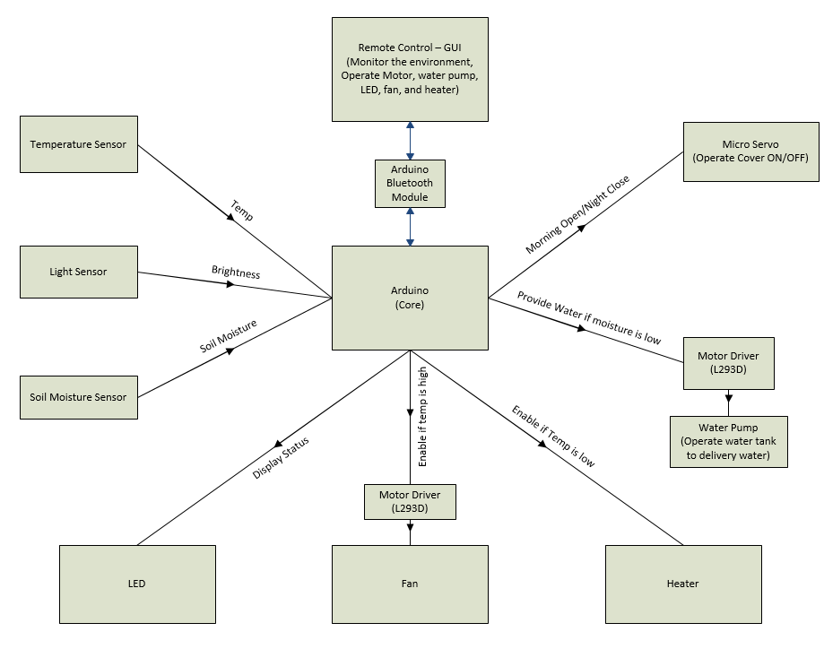

**Input Functions:**

1. **Temperature Sensor:** the sensor can be used to detect and collect air temperature. It can activate the cooler or heater when temperature is higher or lower than set value. The data will be displayed on the both LCD and cellphone app.
2. **Light Sensor:** there are 4 light sensors used to detect the light and activate the cover in mode ON/OFF which installed on the top of case. The mode status will displayed on the both LCD and cellphone app.
3. **Soil Moisture/Humidity Sensor:** the sensor is used to detect and collect the data from the soil, and according to data to activate next step of process.

**Arduino:** Used as main processor, receive data from sensors, transmit data via Bluetooth, and controls micro servo, cooler, heater and water pump.

**LCD:** display status of temperature, soil moisture and output.

**Bluetooth Module:** used to communicate between Arduino and cellphone.

**Output Functions:**

1. **Micro Servo:** used to operate the cover, condition of ON/OFF depends on the light sensor.
2. **Water Pump:** provide water to plants when soil moisture is lower than set value. The water pump works with the L293D motor driver.
3. **LED:** display soil moisture status.
4. **Fan (Cooler):** used to lower the temperature when temperature is higher than set value. The Fan works with the L293D motor driver.
5. **Heater:** used to provide heat to environment when temperature is lower than set value.
6. WBS

|  |  |  |
| --- | --- | --- |
| **Tasks** | **Effort** | **Member Responsible** |
| **1.0 Initiating** |  |  |
| 1.1 Research Information | 3 Days | Together |
| 1.2 Decide Topic | 1 Day | Together |
| 1.3 Learn to Use Arduino | 7 Days | Together |
| 1.4 Oral Presentation | 1 Day | Together |
| 1.5 Write Proposal | 1 Day | Together |
| 1.6 Test Arduino with Sample Code | 2 Days | Together |
|  |  |  |
| **2.0 Planning** |  |  |
| 2.1 Determine Require Parts and Components | 3 Day | Together |
| 2.2 Determine Project Budget | 1 Day | Together |
| 2.3 Evaluate Bill of Materials | 1 Day | Yu Chen |
| 2.4 Design Project Schedule | 1 Day | Huang Zheng |
| 2.5 Make Gantt Chart | 1 DAY | Together |
| 2.5 Assign Tasks | 1 DAY | Together |
| **3.0 Executing** |  |  |
| 3.1 Purchase Parts and Components | 10 Days | Huang Zheng |
| 3.2 Build Circuits on the Breadboard | 5 Days | Huang Zheng |
| 3.3 Test Sensors with Code | 1 Day | Yu Chen |
|  |  |  |
| **3.4 Build Each Individual Parts of Project & Programming Code** | (4 Days) | (Together) |
| ↘ 3.4.1 Cover with Light Sensor | 1 Day | Together |
| ↘ 3.4.2 Soil Moisture Sensor + Water Pump + Motor Driver | 1 Day | Together |
| ↘ 3.4.3 Fan with Motor Driver | 1 Day | Together |
| ↘ 3.4.4 Heater | 1 Day | Together |
| 3.5 Modify | 3 Days | Together |
| 3.6 Combine All Parts Together | 7 Days | Together |
| 3.7 Troubleshooting | 5 Days | Together |
| 3.8 Make PCB & Soldering | 3 Days | Huang Zheng |
| 3.9 Package The Project In a Case | 2 Days | Huang Zheng |
|  |  |  |
| **4.0 Monitoring and Controlling** |  |  |
| **4.1 Control Scope** | (3 Days) | (Together) |
| ↘ 4.1.1 Make Sure Project Meet Requirement | 3 Days | Together |
| **4.2 Control Cost** | (1 Day) | (Together) |
| ↘ 4.2.1 Budgeting | 1 Day | Together |
|  |  |  |
| **5.0 Closing Project** |  |  |
| 5.1 Write Documentation | 3 Days | Together |
| 5.2 Prepare The Presentation | 1 Days | Together |
| 5.3 Final Check of Project | 1 Day | Together |
| 5.4 Submit Project | 1 Day | Together |
| 5.5 Submit Report | 1 Day | Together |
| 5.6 Presentation | 1 Day | Together |

1. GUI



1. Bill of Materials

